Scratch Coding Cards: Getting Started

To get started, you first need to create a new account for yourself in the online program Scratch (https://scratch.mit.edu/). Click "Join Scratch" the first time you access this Web site to set up an account, and next time, just click "Sign In." Scratch runs completely online, and you can save your work online, so you don't need any special computer program on your laptop and you don't have to worry about saving your computer programs to a file or USB drive.
Next, pull ONE of the packs of coding cards out of the cabinet. Don't lose any of the cards, and keep the plastic bag handy. You will need to turn in the cards at the end of class using the plastic bag the cards are stored in. There are ten sets of cards, so you can complete this project ten different times and get credit for each project you complete. The available projects include:
- animate your name
- make music
- race to the finish (game programming)
- hide and seek (game programming)
- create a story
- dress-up
- pong (game programming
- let's dance
- catch (game programming)
- virtual pet
The front of each card tells you what you are going to do, and the back of each card shows you the code to make it happen. Follow the instructions closely and ask for help if you get stuck.
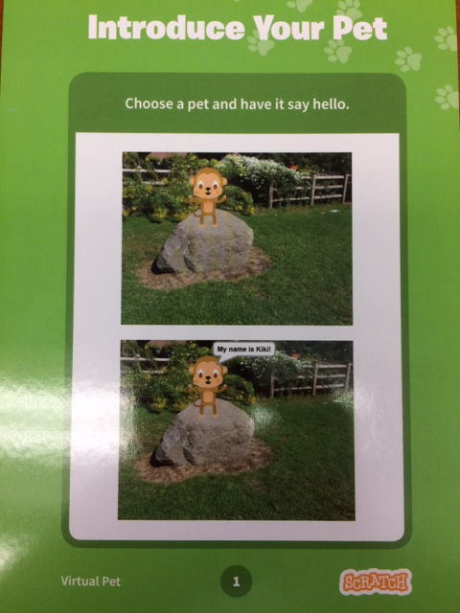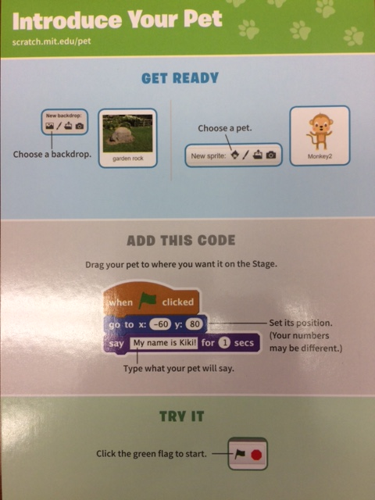

If you need some "basics" instruction on how to use Scratch, these instructional cards may help...

