Paper Mask Instructions

In this project, you will be learning to fabricate a paper mask. The techniques you use to cut out your template, to bend its shapes into different positions, and to assemble by taping together tabs with matching numbers, is closely related to the field of fabrication.

Preparing: The first step in this project is to loosely cut out all of the shapes for your template. Don't cut on the lines yet, just cut near the lines as shown in the photo at right. | 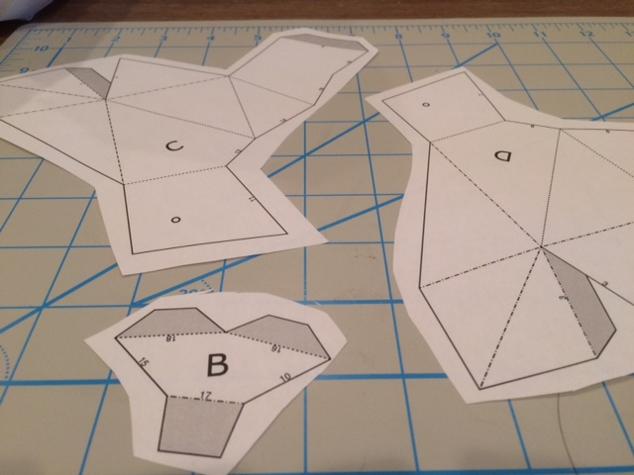
Gluing/Pasting: Next, grab a glue stick or rubber cement, and one piece at a time, cover the back of the piece with glue. It's important to cover the entire back with glue, not just a few places. The piece must be glued down firmly and entirely.  Immediately turn the glued piece over and press it down onto heavier cardstock paper, or if you are fastening your pieces to an old food box, press your pieces down on the side with writing and pictures as shown at right.  Note, if your pieces have been pre-printed on heavier cardstock paper, you can skip this gluing/pasting step, and move on to cutting. | 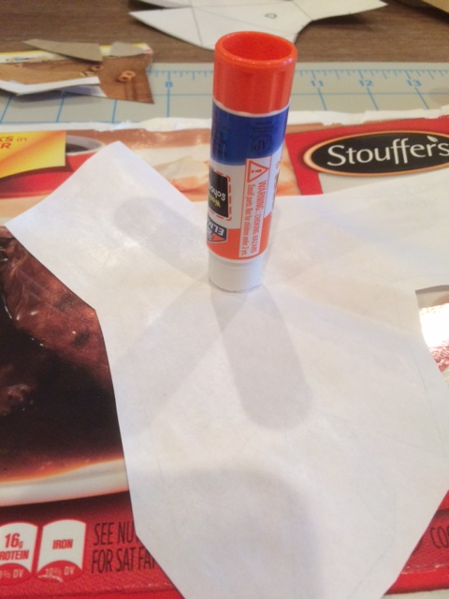
Cutting: Once your pieces have been glued down, cut out the pieces along the SOLID lines only. Don't cut the dashed lines. Don't cut off any of the numbers. You will need to see the numbers later when assembling your mask. | 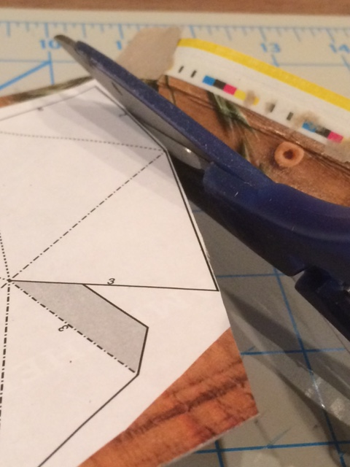
Your cut pieces should look like the example at right. If any of the edges come up, it's okay, just use some glue stick or rubber cement to stick the edges back down. It's common for the paper to come unglued, especially when you start folding. | 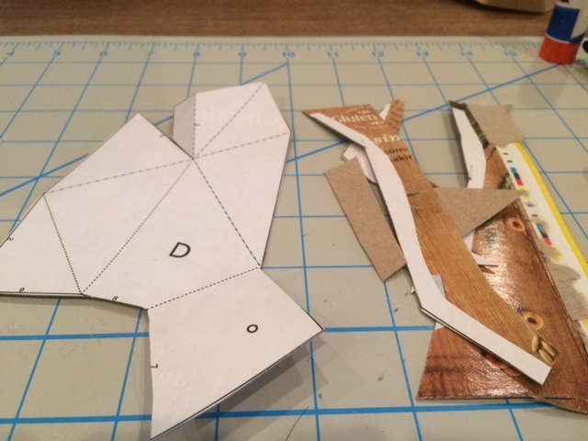
Scoring: Take the tip of a pen or a pizza cutter and score along all of your dashed lines. This will make folding easier. Press hard, but try not to rip the edges of your paper. The club has also purchased access to a scoring tool that will make this step easier (ask a club leader/mentor for a scoring tool). | 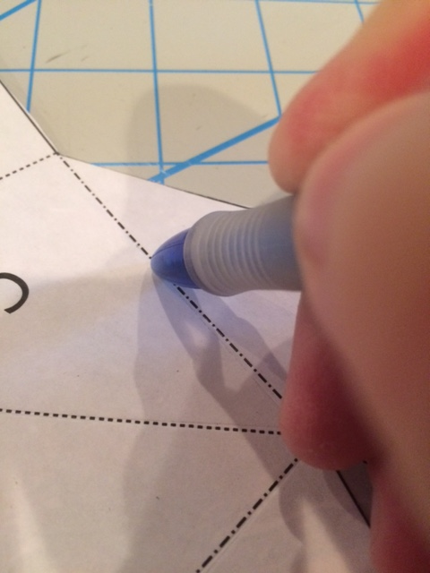
Folding: You will notice two different dashed lines on your pieces. One type of line is all dots, and another type of line is dots AND dashes.  On the lines with dots AND dashes, you will fold the line downward. Think of this as if you are making a "mountain fold." A mountain fold is shown at right. | 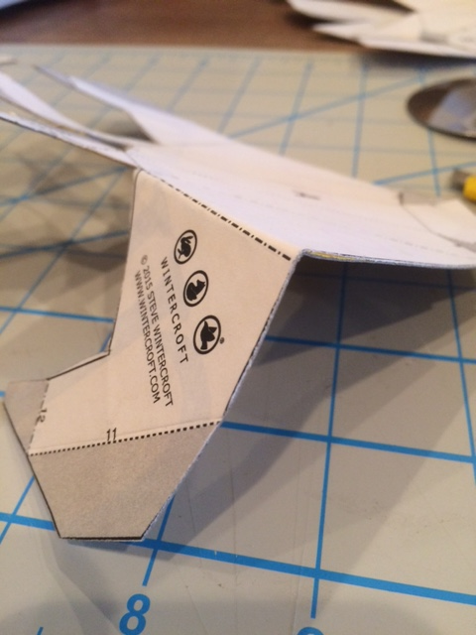
On the lines with dots only, you will fold the line upward. Think of this as if you are making a "valley fold." Several valley folds are shown at right. | 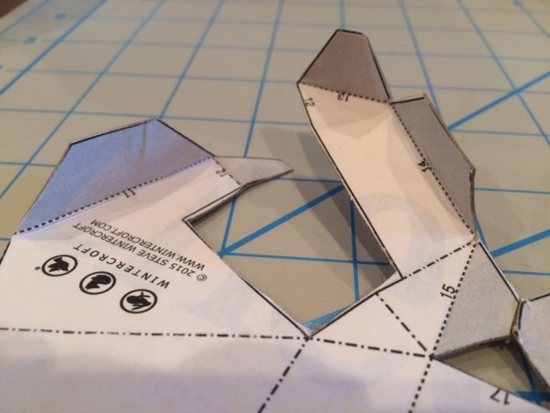
Assembly: The final step in building your mask is to find numbers that match, and start taping those two edges together. Start with piece A, and attach it to piece B. Then attach piece C to combined pieces A-B, and so forth.  The outside of the mask is the side opposite the printed paper and numbers. The shaded tabs should always go on the inside of the mask. In the example at right, you can see that the tabs have been taped on the INSIDE of the mask. | 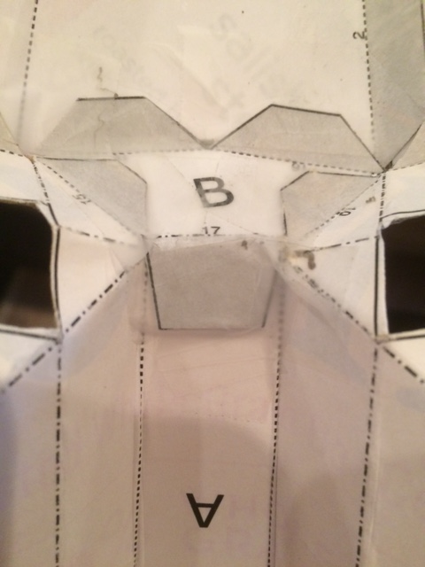

When you are finished taping your mask together, you can attach a small piece of string or a thin rubber band to the back to hold it on your head. You can decorate your mask with markers, or take it home and get a parent to help you paint the mask. Outdoor spray paint is recommended if you intend to take your mask outside and wear it in the elements. Be aware that painting will make your mask heavy, and soaking the paper with wet paint can make some of the pieces and tape come apart. Other applications besides painting are possible, such as a paper mache effect with tissue paper or a metallic look with foil paper (see below).

