Modify a Model
One of the amazing things about 3D printing is that there is a community of designers on the Internet that actively share their 3D models for other people to use and build on. When Dr. Oliver lost the cover for his camera lens, he was able to find a 3D model of that cover that someone else designed and used it to print a replacement.
Your goal for this project is to find an existing 3D model on the Web and modify in some way to make it your own. To accomplish this, start by logging into your TinkerCad account. Next, go to the TinkerCad Design Gallery at https://www.tinkercad.com/things/ and find an object you want to work with. For example, if you wanted to change the design for the spaceship shown below, you would open it up and click the "Copy and Tinker" button to add a copy of that object to your TinkerCad workspace. There, you can modify the object, adding new features or personalization like your name.

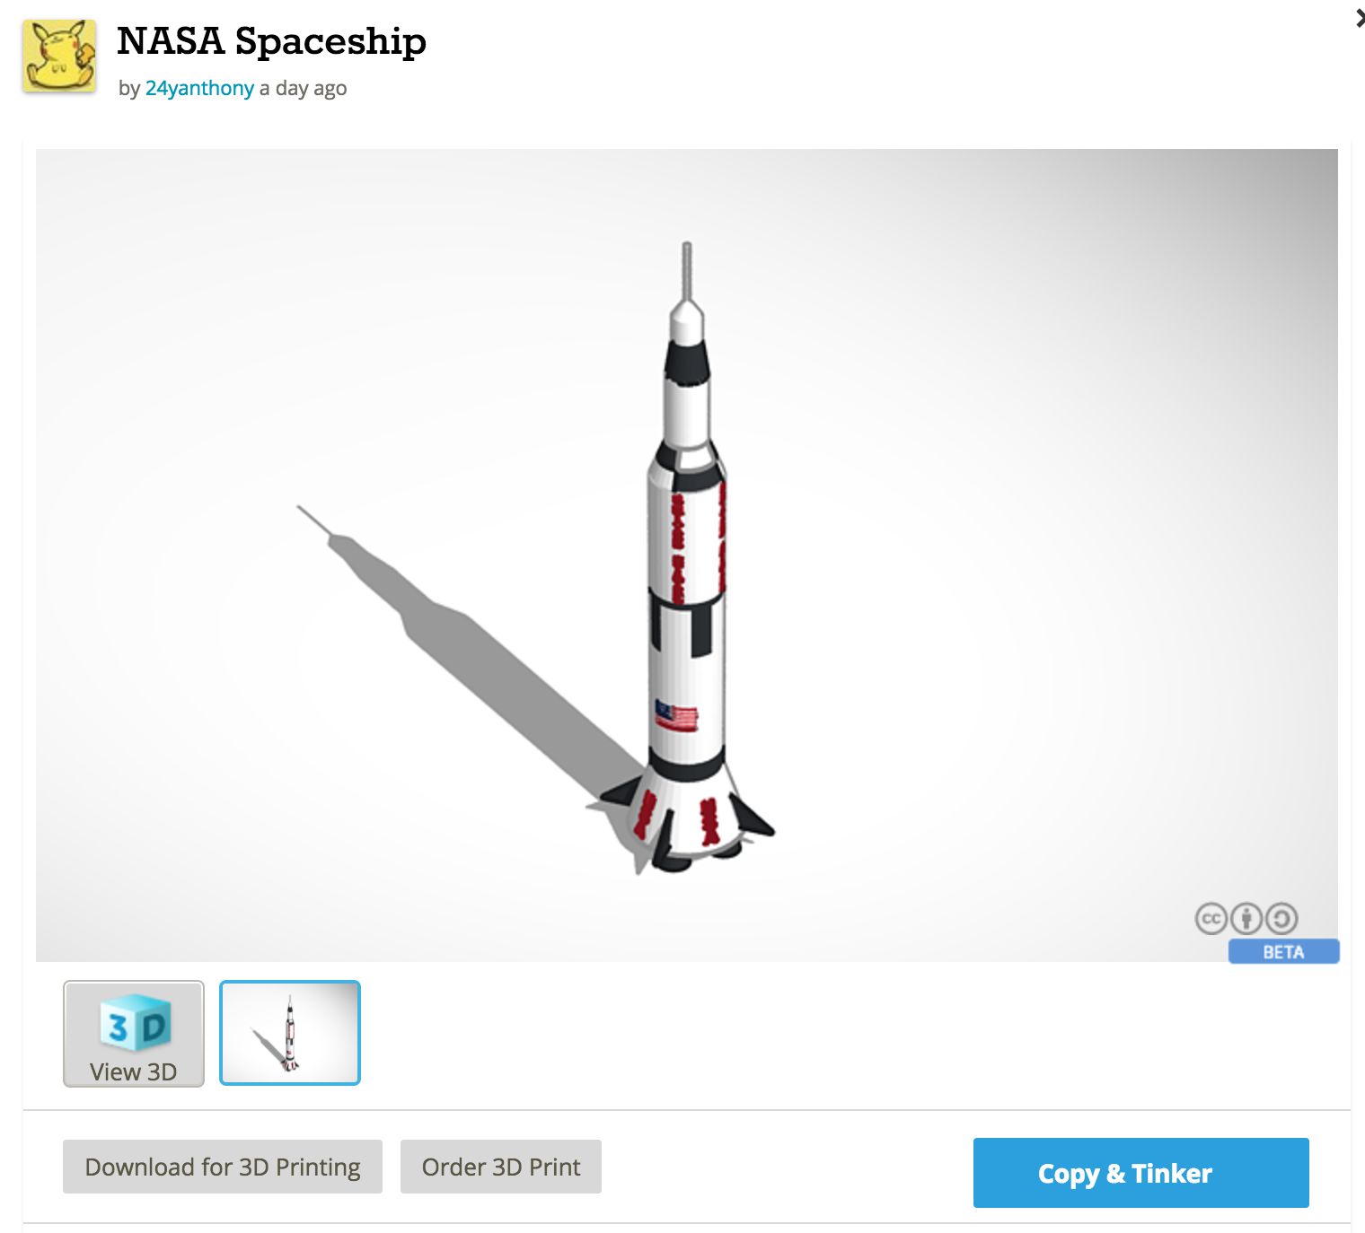

Do This Project Again: You can do this project multiple times and earn credit for every model you design. Submit a separate video in FlipGrid for each model you design.

3D Print Your Object: Start by downloading a .STL model file that is needed to make a 3D print. In TinkerCad, click "Design" and "Download for 3D Printing," and then click the .STL button to download a .STL file. This is the file the 3D printer will need to print your object. Find the .STL file on your computer and drag it to our shared Google folder for 3D printing. Place your file in the folder labeled "1. place new files to be printed here." The club mentors will see your file in this folder and place it in line for printing. The files placed in this folder first will be printed first, based on date/time stamp. We will aim to get everyone’s files printed within a week's time. It takes several minutes to several hours to 3D-print a single object, so you will have to take turns with other club members to 3D print your objects.

