Greeting Card with Copper Foil Circuit

First, make sure you have the following materials on hand to start the project:
- 1 full piece of cardstock paper
- 1 small scrap of transparent tissue paper
- 1 pencil and several multi-colored markers
- 1 pair scissors
- 1 glue stick
- 3-4 strips of copper foil tape
- 1 LED
- 1 coin cell battery
- 1 binder clip

Start by folding your cardstock paper into a greeting card shape. It’s okay if you want to fold the paper differently than shown here. You can fold it horizontally or vertically; it doesn’t matter. You can also cut the card stock paper into a different shape (for example, a square). For the rest of the project, it will be easier if you stick with square shapes, no circles.
The next step is to create your switch for the coin cell battery. Go to the inside of your greeting card and trace the battery in one corner with a pencil. Flip the battery, and trace it a second time. | 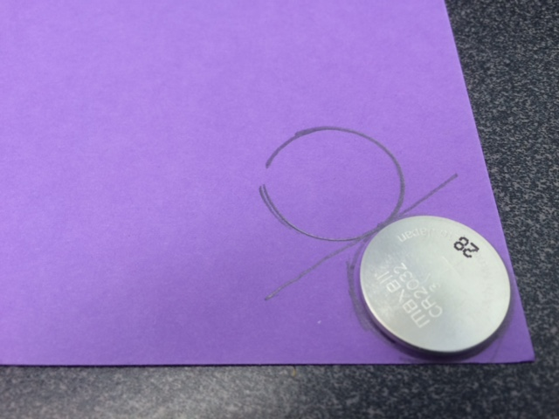
Place a line between the two traces and fold your paper over that line. | 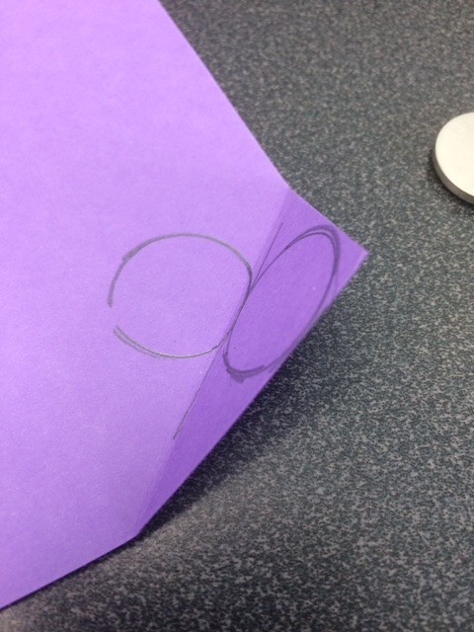
Use markers to create your design for the front of the card. The card can be for a holiday, a birthday, a thank you, a get-well note, etc.

Your design can include a saying like “Happy Birthday” and/or it can include a drawing like a birthday cake. Create part of your design in pencil to cut out. We will put transparent paper behind the cutout, so the LED light shines through. For example, if you had a birthday cake with a candle on it, a good place to make your cutout would be behind the candle.

Use scissors to make your cutout, and find a scrap piece of tissue paper to put over the hole. | 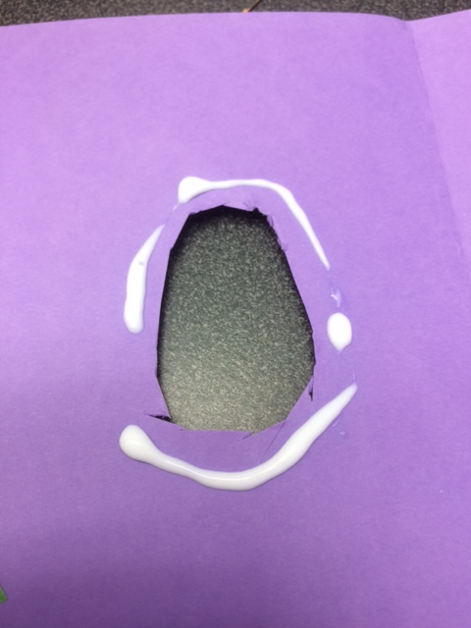
Glue the tissue paper down. A glue stick works best; regular glue will bleed through the tissue paper.
Make a pencil mark opposite your cutout. This is where the LED will go to shine through your transparent tissue paper.
Take a strip of copper foil tape and start a line at the center of your first pencil-drawn circle. Repeat for the other circle. You can be creative with your tape lines and use them to make a shape like a flower, but the tape line coming out of one circle should never touch the tape line coming out of the other circle. They must not overlap. | 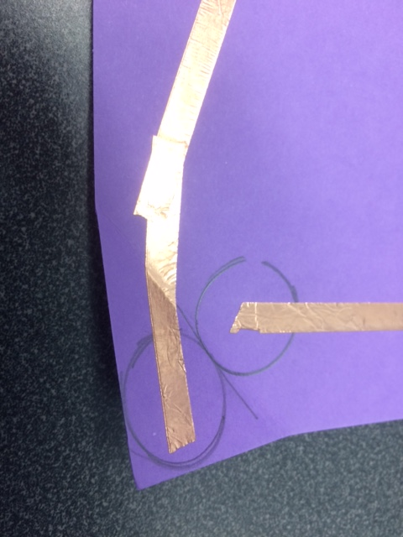
Your circuit should look something like the example at right. You have one line or copper foil tape coming out of the first circle, and a second line of copper foil tape coming out of the second circle. These lines should never touch. Leave a gap in the two tape lines at the top, where you will insert your LED. | 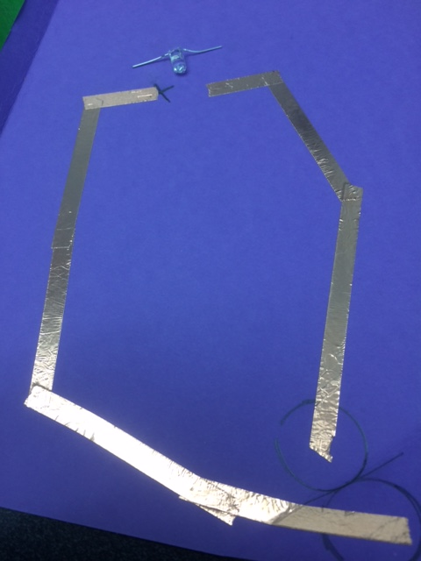
Bend the two legs of your LED down so that the LED will lie flat. Take notice of which prong of the LED has a longer leg—that is the positive side. You will need to touch the positive + side of the coin cell battery to the copper foil line that leads to positive leg of your LED.  Use two small pieces of copper foil tape to tape your LED down to the circuit. | 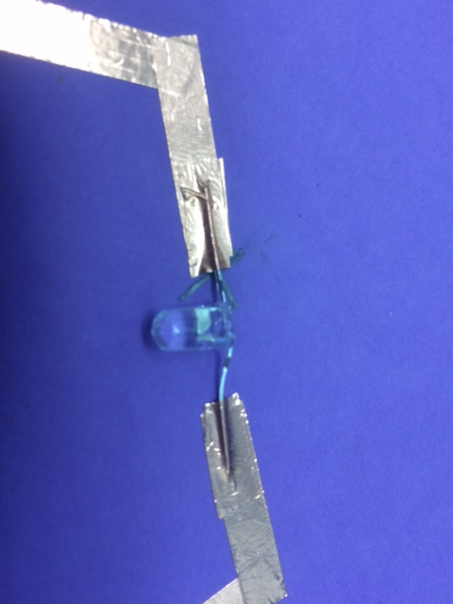
Place the coin cell battery in your switch and fold the switch closed. | 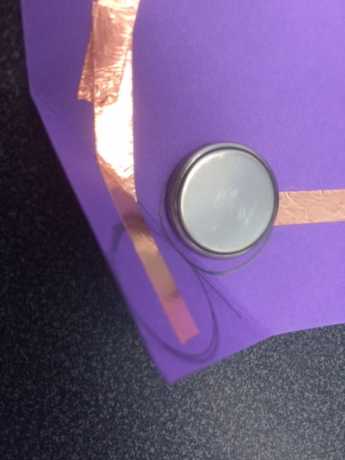
When your coin cell switch is closed, the LED should light up. | 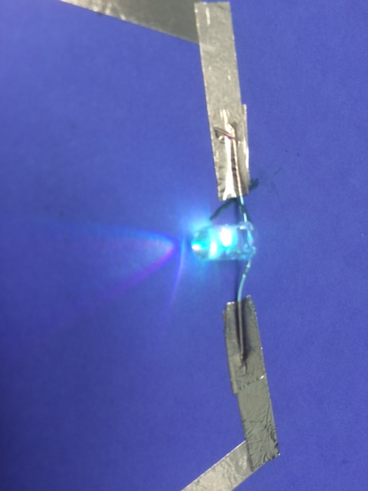
You can use a small binder clip to keep your switch closed and the LED lit. | 