More Hummingbird Project Ideas

Animate an Animal (e.g., elephant’s trunk, rabbit’s mouth that starts nibbling when a carrot is inserted)
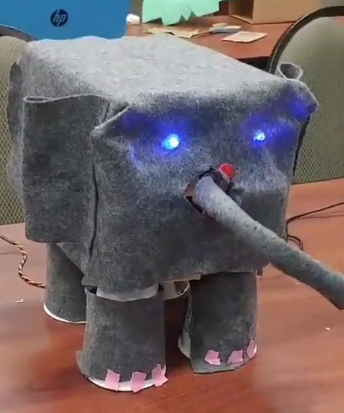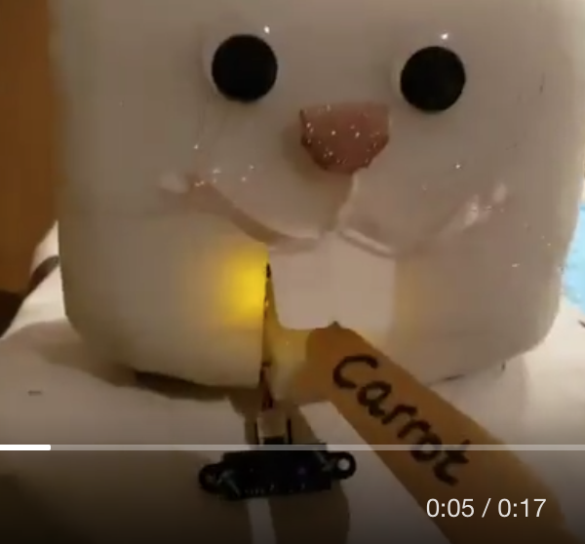

Animate a Famous Work of Art
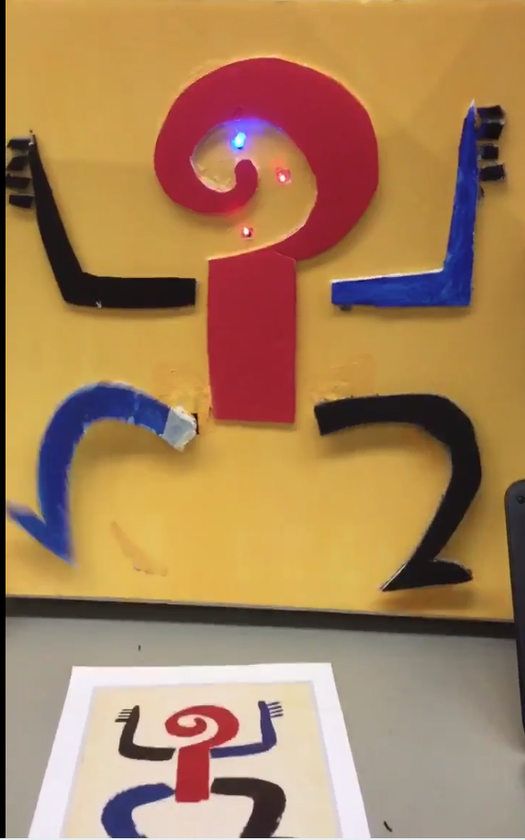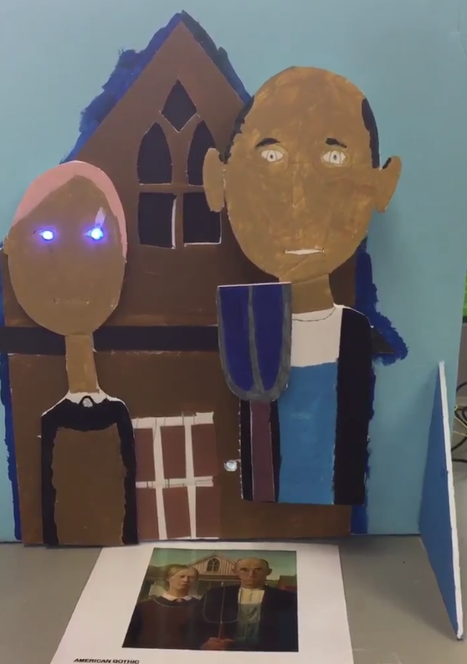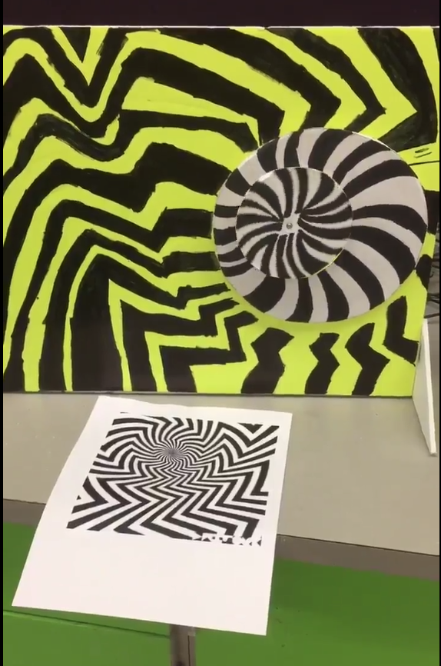

Animate a Sports Figure (e.g., throwing motion of a pitcher’s arm)  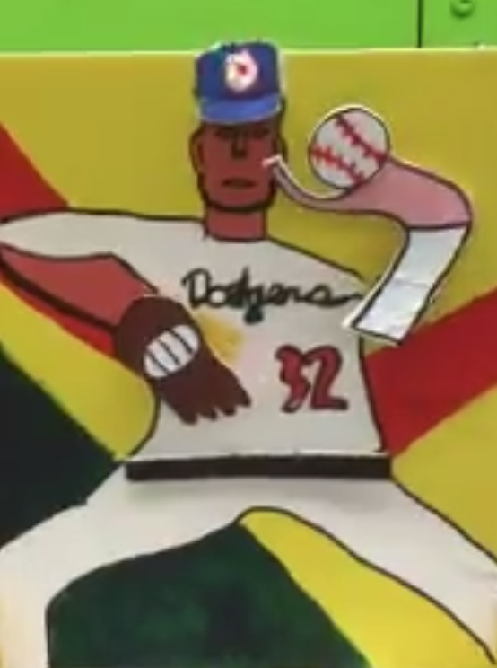 | Animate a Character from a Popular Book (e.g., Where the Wild Things Are)  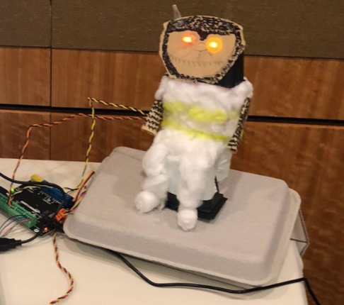
Make a Game (e.g., “Operation” where an LED goes off or a vibration motor rings a bell if you get too close to a sensor, or a throwing game where hands move randomly to try and keep you from getting a ball by them)
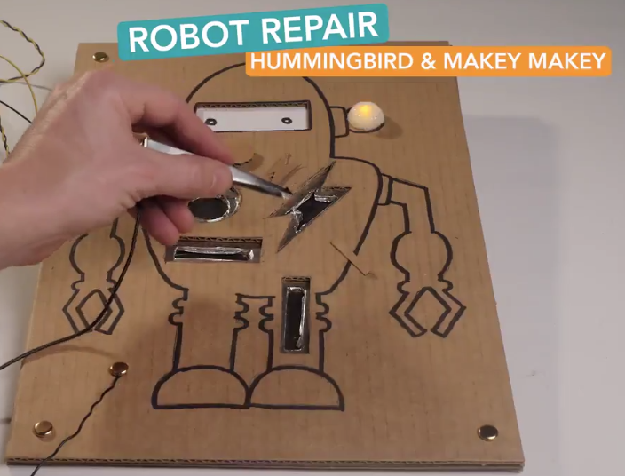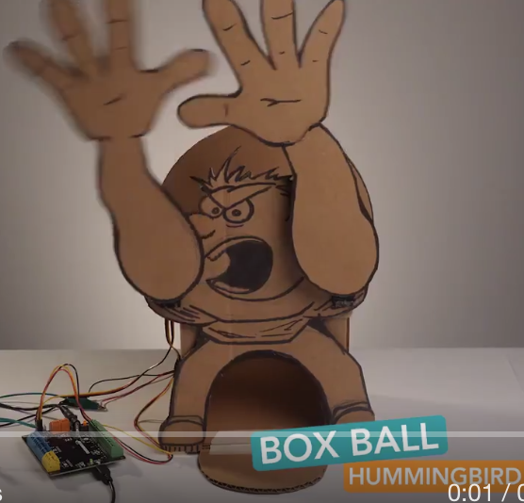

Use Popsicle Stick to Create a Mechanism that Opens a Door/Eyes, Throws an Object, or Moves an Object Up and Down (for mechanism examples, see, https://www.youtube.com/watch?v=AQxdTrZ1Y_k&t=1s)
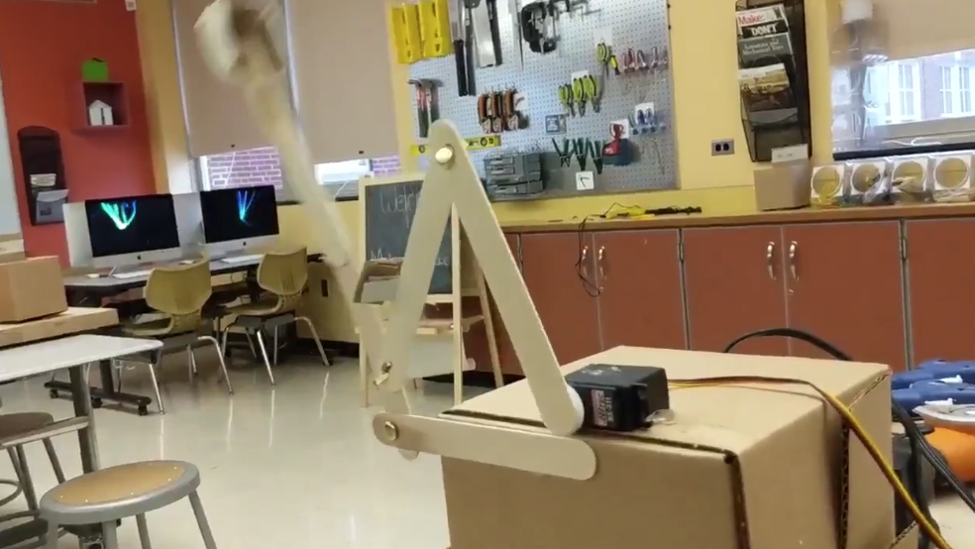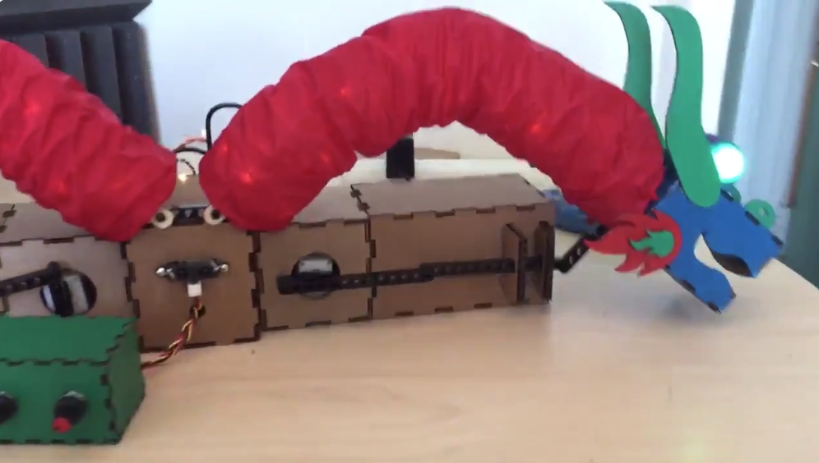

Create a moving barrier that blocks a hole on a miniature golf course (e.g., windmill, animal)
