Instructions: Getting Started with TinkerCad Software for 3D Printing

Students, to get started with 3D printing, you will need to learn how to use a software program called TinkerCad. TinkerCad allows you to design 3D objects. When you are finished creating a 3D design, you export the design as a specific type of file that a 3D printer can read--an .STL file. We then use a different piece of software on one of the laptops (Cura) to send your .STL file to the 3D printer and start your 3D print.

Sign Up for Account: Your first goal should be to learn how to use TinkerCad. To get started, go to http://tinkercad.com and click “Login” to sign up for a free Autodesk account. Be sure to remember your log-in name and password, so you can save any unfinished files at the end of a club meeting and get back in to work on them in future club meetings.

Get a Mouse: After setting up your account, go to the cabinet in the classroom and get out a 3-button, scroll-wheel mouse to plug into your laptop and use with TinkerCad. Any time you use TinkerCad, be sure to get a 3-button, scroll-wheel mouse, as it is much easier to use TinkerCad when you have an external mouse plugged into your laptop.

Complete the Basics Lessons:  Go to https://www.tinkercad.com/learn/ and work through the six "Basics" lessons shown at right to learn how to use TinkerCad. Pay attention as you work on these fun interactions, as you will need to learn the basics of this TinkerCad program before you can design your own 3D objects. | 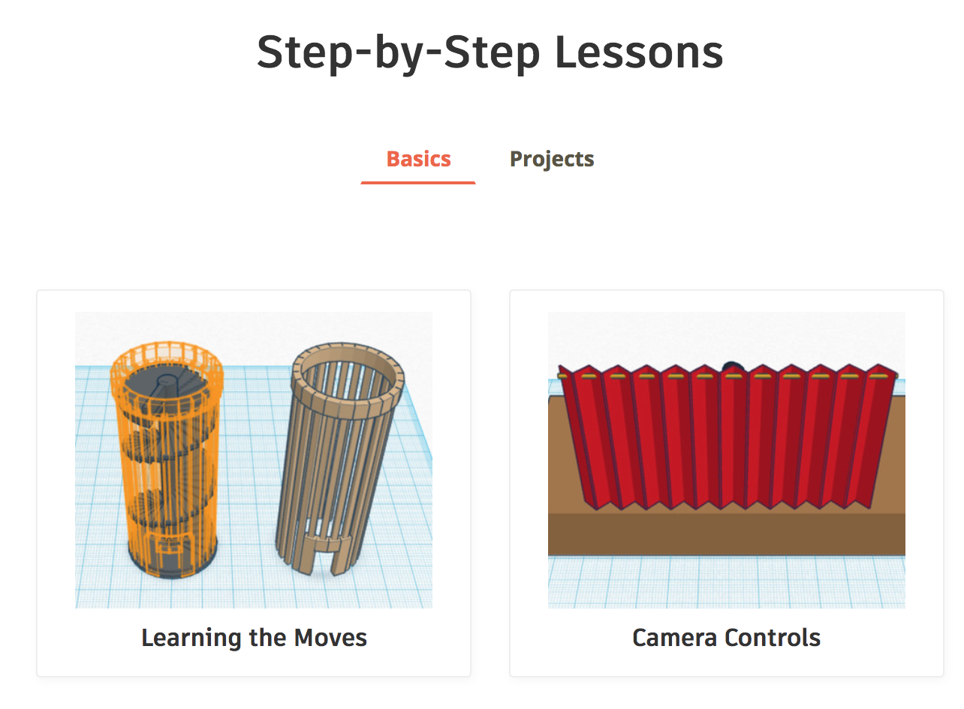

Complete Project Lessons: After working through the six "Basics" lessons at https://www.tinkercad.com/learn/, click the link next to “Basics” for “Projects” and choose a project to work on. Making a personalized key chain is a good project to start with. After you finish a project, see the instructions below to submit your file for 3d-printing. | 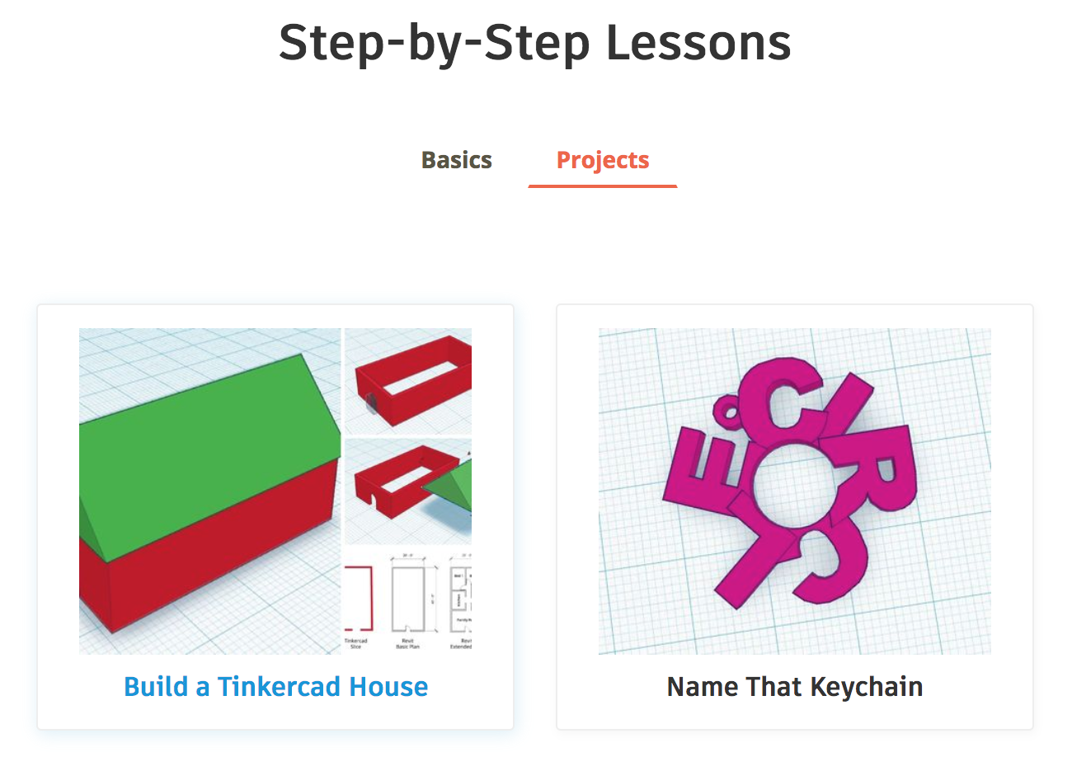

Submit Files for Printing: If you created something original in these lessons that you want to print (e.g., a key chain), you may submit these files for 3d-printing. We ask you NOT to submit everyday tutorial objects like a square box or cylinder just for the sake of printing. If you do want to print something unique, you will have to export an .STL 3d model file to your computer. Next, find that file and drag a copy into our shared folder for 3D printing. Place your file in the folder "place new files to be printed here." The club mentors will see your file in this folder and place it in line for printing. The files placed in this folder first will be printed first, based on date/time stamp. We will aim to get everyone’s' files printed within a week's time.

Next Steps: After printing some of the Tinkercad projects, you are ready to start designing your own 3d objects for printing! Be creative and have fun!

