Design Your Own Original Model

We use so many objects in our daily lives that someone had to design from scratch--paper clips, hair clips, light switches, door knobs, cell phones, cups, plates, forks, tools. All of these objects were designed by someone to solve some type of problem. Your goal in this quest is to think about a problem in your daily life or someone's daily life that can be solved with a 3D object. Then you have to design the object from scratch in TinkerCad and turn it in. Please note, you can't get credit for this quest unless your object solves some problem. You can't just turn in a 3D object that has no purpose (e.g., a piece of jewelry that you wear, a super hero's cape, a personalized key chain). Rather, the object must serve a purpose. For example, one designer talked to his brother and found out he would like his match box car track to hang on the wall, so he designed a clip that allowed his brother's match box track to hang on the wall (see pic below). What problems can you think of, and what 3D solutions can you design? Be creative! If you get stuck, it might help to take a look at what other people are designing. You can browse the different "gadgets" that people have designed on this AutoDesk site. or take a look at the objects at this Thingiverse site.

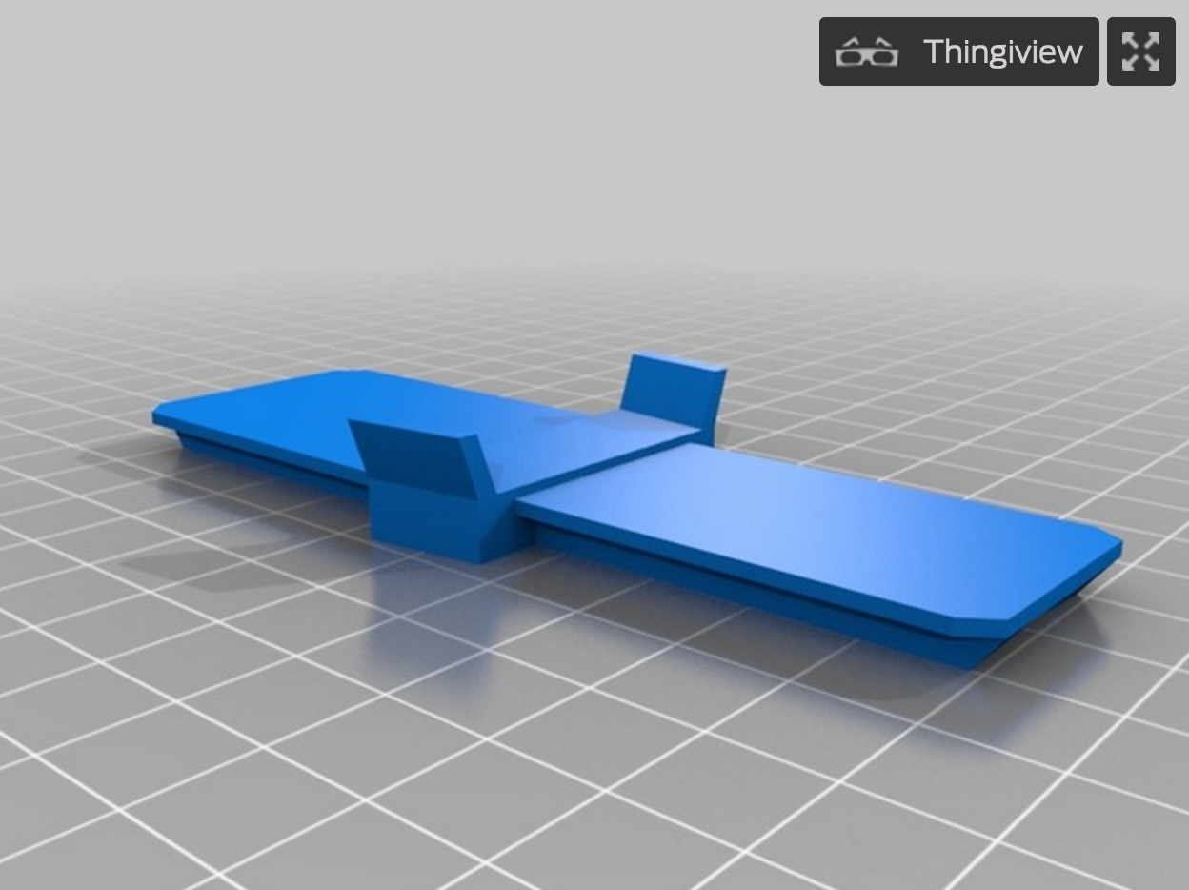

Do This Project Again: You can do this project multiple times and earn credit for every model you design. Submit a separate video in FlipGrid for each model you design.

3D Print Your Object: Start by downloading a .STL model file that is needed to make a 3D print. In TinkerCad, click "Design" and "Download for 3D Printing," and then click the .STL button to download a .STL file. This is the file the 3D printer will need to print your object. Find the .STL file on your computer and drag it to our shared Google folder for 3D printing. Place your file in the folder labeled "1. place new files to be printed here." The club mentors will see your file in this folder and place it in line for printing. The files placed in this folder first will be printed first, based on date/time stamp. We will aim to get everyone’s files printed within a week's time. It takes several minutes to several hours to 3D-print a single object, so you will have to take turns with other club members to 3D print your objects.

